Graph Theory - Tutorial 3 Solutions
SMA116 – Discrete Mathematics 1B
Question 1
Suppose a computer takes 1 microsecond (a millionth of a second) to execute each operation. How long will it take for the computer to execute each of the following numbers of operations?
- 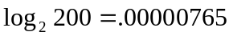 | - 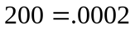 seconds
- 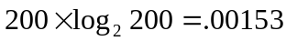 seconds | - 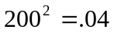 seconds
- 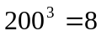 seconds | - 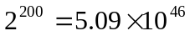 years
Question 2
For each of the following algorithm segments, assume that n is a positive integer and
- Compute the number of additions, subtractions, multiplications, divisions, and comparisons that must be performed when the algorithm segment is executed;
- Show that the algorithm segment has the specified complexity.
- for 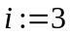 to 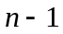  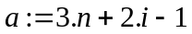  next i  complexity: O(n) | - Number of operations is 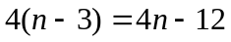.  - O(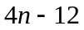) = O(n)
- 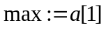  for 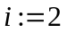 to  if 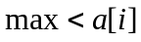 then 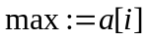  next i  complexity: O(n) | - Number of operations is 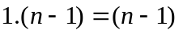.  - O() = O(n)
- for 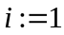 to 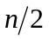  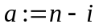  next i  complexity: O(n) | - Number of operations is 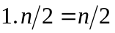.  - O() = O(n)
- for to n  for 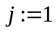 to 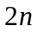  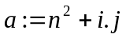  next j  next i  complexity: O(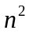) | - Number of operations is 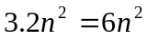.  - O(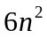) = O()
- for 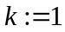 to  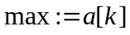  for 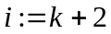 to n  if then  next i  next k  complexity: O() | - Number of operations is 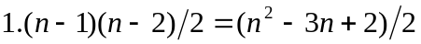  - O(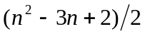) = O()
This is a trickier question as the value of k changes with each iteration of the inner loop. To work out the number of times through the inner loop consider the table below:
k | 1 | 2 | … | 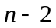
i | 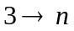 | 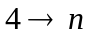 | … |  | none | none
Therefore the inner loop is executed 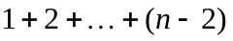 times. We know that
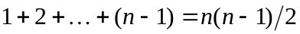
Hence, substituting 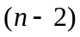 for 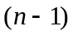 gives:
So the inner loop is executed 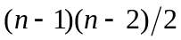 times. We have one operation to consider (the comparison) which is inside the inner loop so the number of operations must be 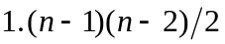.
See Epp page 498 for more details on this method.
- for to n  for 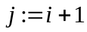 to n  if 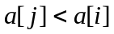 then do  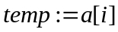  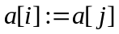  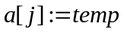  end do  next j  next i  complexity: O() | - Number of operations is 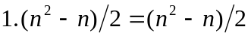.  - O(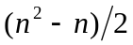) = O()
- for to n  for to 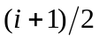  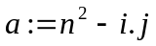  next j  next i  complexity: O() | - Number of operations is 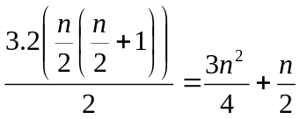.  - O(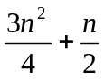) = O()
Question 3
Calculate for
- therefore 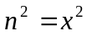 | - 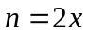 therefore 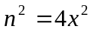
When the value of n given in parts (a) and (b) increases by a factor of 2, by what factor does increase?
It increases by a factor of 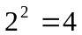.
What does this tell you about the relationship between the two values of n, and the corresponding values of ?
Question 4
Calculate for
- therefore | - 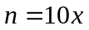 therefore 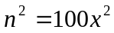
When the value of n given in parts (a) and (b) increases by a factor of 10, by what factor does increase?
It increases by a factor of 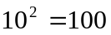.
What does this tell you about the relationship between the two values of n, and the corresponding values of ? Consider what it means in terms of Question 3 – how does increasing n by a factor of 2 compare to increasing it by a factor of 10?
Question 5
Given that 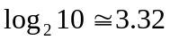 and 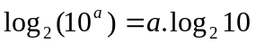for all real numbers a, calculate:
- 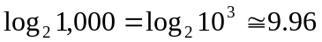 | - 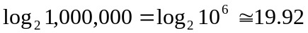
Question 6
Given your answers in Question 5, generalise your results and comment on the following:
- Consider 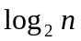. If we square n, by what factor does increase?
A factor of 2.
- By what factor does increase if we raise n to the tenth power.
A factor of 10.
- When n is increased from 100 to 10,000,000,000, by what factor is increased?
A factor of 8.

